Anti-Bullying Week

Being a Safer Schools Officer, I support Anti Bullying Week as there is no place for bullying at the Constance Bridgeman Centre..

Kindness is more important today than it has ever been. The isolation of the last year has underlined how little acts of consideration can break down barriers and brighten the lives of the people around us.

This is one of the reasons that ‘One Kind Word’ has been chosen as the theme of Anti-Bullying Week taking place from 15th to 19th of November 2021.
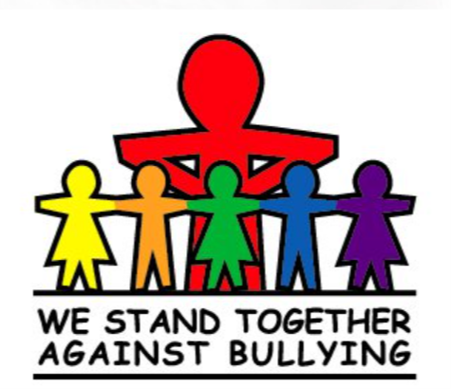

Where and When Bullying Happens
Bullying can occur during or after school hours. While most reported bullying happens in the school building, a significant percentage also happens in places like outside the school or the bus. It can also happen travelling to or from college.

Types of Bullying
There are three types of bullying:
Verbal bullying is saying or writing mean things. Verbal bullying includes:
  - Teasing
  - Name-calling
  - Taunting
  - Threatening to cause harm
Social bullying, sometimes referred to as relational bullying, involves hurting someone’s reputation or relationships. Social bullying includes:
  - Leaving someone out on purpose
  - Telling other children not to be friends with someone
  - Spreading rumours about someone
  - Embarrassing someone in public

Physical bullying involves hurting a person’s body or possessions. Physical bullying includes:
  - Hitting/kicking/pinching
  - Spitting
  - Tripping/pushing
  - Taking or breaking someone’s things
  - Making mean or rude hand gestures
Together we can:
Ask if someone’s OK
Be KIND to one another
Tell the bully to STOP

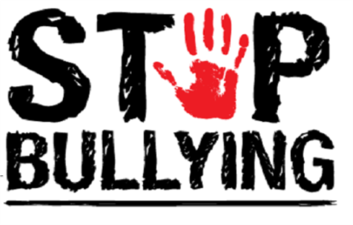

PC GRIGG 1136EA

