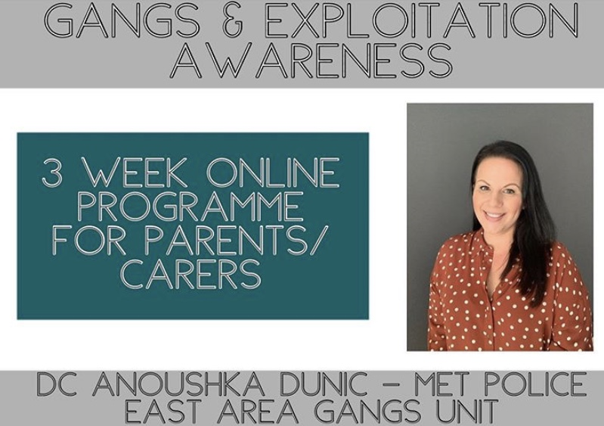

This commended FREE course is now available online for ALL parents and carers in Barking & Dagenham, Havering and Redbridge! The course is 3 weeks long, with a 2 hour ONLINE session per week.

This round will be delivered on Microsoft Teams (This App can downloaded on phones, tablets or laptops).

The dates for this course are THURSDAYS 8th, 15th and 22nd at 7:30-9:30pm (all sessions to be attended)

Gangs & Exploitation Awareness Training for Parents and Carers–
We will be discussing the following topics-

- What street gangs are and what they do.
- To understand some of the language/social media used by gangs and young people.
- Looking into the term “county lines”
- The different stages of exploitation and recognise some of the signs and symptoms of children who may have been exploited.
- Stress responses and behaviour.
- Some of the reasons children may be more vulnerable to exploitation by gangs and the link to childhood trauma.
- The trauma experienced by children and young people involved in gang lifestyles.
- “Attachment” and the need for strong, nurturing attachments between parent/caregiver and child.
- Resilience in children.
- Parenting tools.
- Why our children may resist help/support from services.

To book your space please email Anoushka.Dunic@met.police.uk or text/call direct on 07741686764. You can remain anonymous and be as interactive as you feel comfortable with.

